**1.Write a program to read a length in inch scale and convert it in the centimeter scale.**

**Code:**

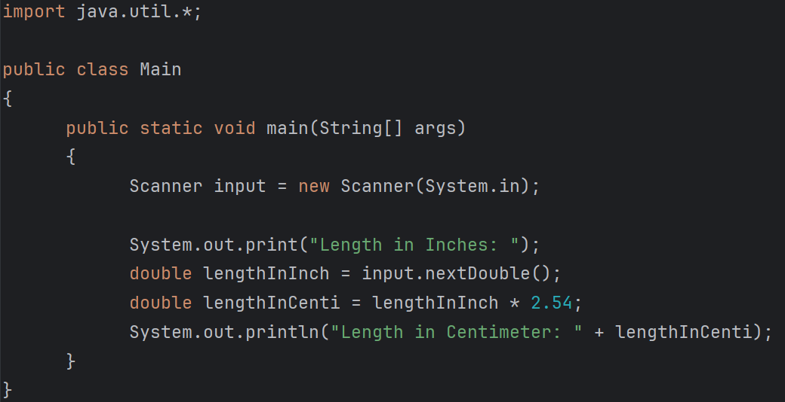

**Input - Output:**

